A specific computational role for early-life unpredictability, and not lifetime traumatic experience, in decision-making under uncertainty.
Yifan Zhang^{1,2, ∗} Yifei Chen^{3, ∗} Rohin Palsule¹ X. Roger Chen¹ Nora C. Harhen⁴ Laura M. Glynn⁵ Elysia Poggi Davis^{6, 8}
Tallie Z. Baram^{7,8,9,11,12,13,14} Victoria B. Risbrough^{10,11} Daniel M. Stout^{10,11} Aaron M. Bornstein^{1,2,12,13,14,15}

¹ Department of Cognitive Sciences, University of California, Irvine, CA, USA
² Center for Theoretical Behavioral Sciences, University of California, Irvine, CA, USA
³ Department of Psychology, Princeton University, Princeton, NJ, USA
⁴ Department of Psychology, New York University, New York, NY, USA
⁵ Department of Psychology, Chapman University, Orange, CA, USA
⁶ Department of Psychology, University of Denver, Denver, CO, USA
⁷ Department of Anatomy & Neurobiology, University of California, Irvine, CA, USA
⁸ Department of Pediatrics, University of California, Irvine, CA, USA
⁹ Department of Neurology, University of California, Irvine, CA, USA
¹⁰ Department of Psychiatry, University of California, San Diego, CA, USA
¹¹ Center of Excellence for Stress and Mental Health, Veterans Affairs San Diego Healthcare System, San Diego, CA, USA
¹² Center for the Neurobiology of Learning and Memory, University of California, Irvine, CA, USA
¹³ Drury Institute for Translational Depression Discoveries, University of California, Irvine, CA, USA
¹⁴ Center for Early Life Environment and Neuropsychiatric Outcomes, University of California, Irvine, CA, USA
¹⁵ Department of Neurobiology & Behavior, University of California, Irvine, CA, USA

Correspondence: yifaz79@uci.edu

Abstract
It has been shown that early-life adversity (ELA) is associated with how individuals learn, remember, and make decisions, yet the precise computations altered by these experiences remain unclear. Here, we combined a structured foraging task with computational modeling to test a recently developed theory for how a particular kind of ELA, early-life unpredictability (ELU), specifically influences choice under uncertainty. Adult participants (N=147) performed a sequential foraging task requiring continuous trade-offs between exploiting depleting resources and exploring alternatives. A subset of participants also completed assessments of early-life unpredictability (QUIC), PTSD symptoms arising from lifespan trauma exposures (PCL), and lifetime trauma exposure (LEC-5). We fit participants’ behavior with an adaptive discounting model in which uncertainty modulates the valuation of leaving a current resource patch. The subjective influence of local uncertainty was allowed to vary freely between participants.
Consistent with theoretical proposals, computational model fits and mediation analyses revealed a robust indirect pathway: ELU predicted increased discounting in the face of uncertainty, which in turn predicted greater overharvesting. This pattern was consistent across environment richness, indicating that early-life unpredictability primarily influences behavior through a general influence on uncertainty processing. Importantly, though PCL and LEC scores also predicted uncertainty-adaptive discounting, these relations did not survive controlling for shared variance with ELU. These findings dissociate developmental unpredictability from both current traumatic stress symptom severity and cumulative lifetime trauma exposure. Together, our results suggest that early-life experience is specifically associated with long-lasting changes in decision-making through amplified subjective weighting of uncertainty.

Introduction
Early-life unpredictability (ELU) has been proposed as a critical developmental factor influencing learning and decision-making (Glynn et al., 2019; Birnie and Baram, 2022; Decker et al., 2025; Rachum et al., 2025; Davis & Glynn 2024). Exposure to unstable or unpredictable environments during development may alter how individuals represent and respond to uncertainty, potentially leading to persistent differences in choice valuation and action selection. Prior work has linked ELU to risky behaviors (Spadoni et al., 2022) and differences in affective processing (Glynn et al., 2019). A recent theoretical framework suggests that these behaviors are consistent with amplified uncertainty signals arising from adaptations during a critical period of high plasticity (Harhen and Bornstein, 2024). Here, we test this proposed specific computational role directly.

One promising framework for addressing the specific computational role in question is patch foraging, a decision behavior widely understood to engage naturalistic, evolutionarily-conserved mechanisms (Blanchard and Hayden, 2015). In canonical models (Charnov, 1976), decisions to leave a patch depend on a comparison between the expected value of staying and the average reward rate of the environment. When environmental structure is uncertain, agents must infer latent dynamics to estimate local and global patch richness, and adjust their decision policies accordingly (Harhen and Bornstein, 2023; Harhen et al., 2026; Chen et al., 2026). This suggests that individual differences in how uncertainty is estimated could lead to systematic variation in foraging behavior.

Later-life trauma and acute stresses also affect uncertainty processing (De Berker et al., 2016; Morgado et al., 2015; Verfaellie et al., 2025). Lifelong experiences of trauma could both affect the content of self-report and also yield similar mental health outcomes as do early-life experiences [Verfaellie et al., 2025; Bird et al., 2024; Sailer et al., 2014 ]. An open question for the field is whether the impact of these separate events on cognition can be dissected in adult behavior.

Here, we combine a sequential foraging task with computational modeling to test the hypothesis that ELU modulates uncertainty-dependent weighting of reward. Participants completed a foraging task with patches of varying reward richness. Rewards within each patch depleted over time, compelling participants to choose whether to continue harvesting the declining rewards or pay a travel cost for the possibility of transiting to a less (or more) rewarding patch. They also completed assessments of early-life unpredictability (QUIC) and trauma-related symptom severity (PCL). We fit participants’ choices with a Bayesian learning-and-adaptive discounting model (Harhen and Bornstein, 2023; Harhen et al., 2026; Chen et al., 2026) in which trial-by-trial uncertainty about the participants’ position in latent state space adaptively modulates the value of leaving, captured by an uncertainty-dependent discount factor. Consistent with prior theoretical work on the consequences of ELU for neural coding (Harhen and Bornstein, 2024),we hypothesized that individuals with greater ELU would exhibit increased sensitivity to uncertainty, which formal theory suggests should be reflected in modulation of decision values by local uncertainty (Jiang et al., 2015), specifically via a reduction in planning horizon. Furthermore, we tested whether this relation is specific to ELU or can also be explained by lifelong trauma-related symptom severity. By linking early life experience to computational parameters governing decision-making, via normative models that formalize rational responses to life experience and environmental conditions, this work aims to provide a mechanistic account of how developmental environments could shape adaptive behavior in uncertain and dynamic contexts.

Materials and Methods

Participants
147 participants were recruited from Amazon Mechanical Turk (87 females, 59 males, 1 others, 9 unknown; 52.99 ± 1.28 years old) between May 3 and July 2, 2024, using the CloudResearch Approved Group Filter. They received a base payment of $15.00 for completing the patch-leaving task, with a potential bonus of up to $5.00 contingent on performance on two randomly selected planets. All participants also filled out the Questionnaire of Unpredictability in Childhood (QUIC), the Life Event Checklist (LEC-5) and the Post-Traumatic Stress Disorder Checklist for DSM-5 (PCL-5), for an additional $5.00 compensation. The recruitment was limited to participants who (1) had a minimum 95% approval rate, (2) had completed at least 50 approved tasks, and (3) were located in the United States. Inclusion criteria required that participants (1) passed the instruction quiz with fewer than three attempts, (2) passed both attention checks, (3) had a mean residence time within two standard deviations of the group average, and (4) spent on average at least two digs per planet to ensure sufficient exposure to patch types.

Data Analysis
Model fitting and parameter recovery analyses were performed on Julia 1.11.7. All subsequent data processing, statistical analyses, and visualization were performed in Python 3.12.4. To avoid assuming linear relationships or normally distributed variables, correlation analyses were conducted using Spearman’s rank correlation coefficient unless otherwise specified.
Experiment Setup
Participants completed an online serial stay–switch foraging task adapted from prior human foraging tasks (e.g. Constantino and Daw, 2015). The primary way that the task differs from previous work is that it elicits behavior in the presence of multiple patch types (Harhen and Bornstein, 2023; Harhen et al., 2026; Chen et al., 2026). Participants were instructed to maximize total reward by traveling between planets and mining “space gems” across five blocks of fixed duration (6 minutes each), separated by self-paced breaks of up to one minute.
Upon arrival at a new planet (Fig. 1A), participants performed an initial dig and received a gem reward sampled from a Gaussian distribution (mean = 100, SD = 5). After each dig, they decided whether to stay on the current planet or leave to travel to a new one. Staying allowed immediate continuation of access to the current planet’s (depleting) resources, whereas leaving incurred a longer travel delay but granted access to a replenished gem mine. Participants had up to 2 seconds to respond; missed responses resulted in a brief timeout.
In order to isolate the effect of structure alone, temporal costs were controlled so that reaction time did not directly affect reward rate. Stay decisions were followed by a 1.5-second delay before reward feedback, with total trial duration held constant. Leave decisions incurred a 10-second travel delay, followed by arrival on a new planet before mining resumed. Planets differed in richness, defined by the rate at which rewards decayed exponentially with successive digs. Three planet types were used—poor, neutral, and rich—with decay rates sampled from beta distributions producing fast, intermediate, and slow depletion, respectively (Fig. 1B). Environmental structure extended across planets. When traveling to a new planet, there was an 80% probability that it would be of the same type as the previous planet and a 20% probability of switching to one of the other two types (Fig. 1C). This transition structure was not disclosed to participants.
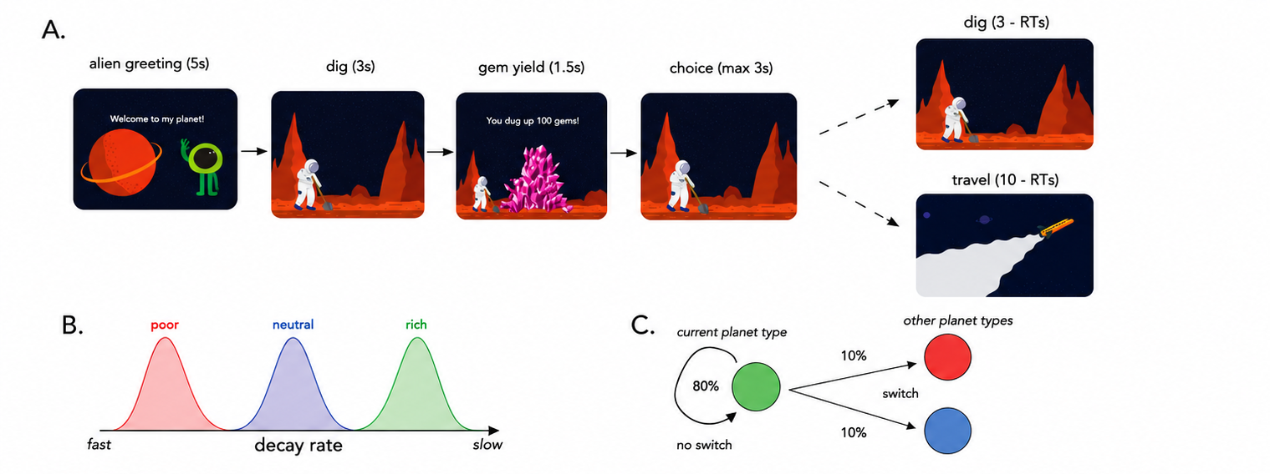
Figure 1: Planet Foraging Task: (A) Serial stay-switch task. Participants traveled to different planets and mined space gems across five 6-min blocks. On each trial, they had to decide between staying to dig from a depleting gem mine or incurring a time cost to travel to a new planet. (B) Environment structure. Planets varied in their richness or, more specifically, the rate at which they exponentially decayed with each dig. There were three planet types: poor, neutral, and rich—each with its own characteristic distribution over decay rates. (C) Environment dynamics. Planets of similar type clustered together. A new planet had an
0.8 probability of being the same type as the prior planet (“no switch”). However, there was a 0.2 probability of transitioning or “switching” to a planet of a different type–equally distributed among each different planet type. (Figure adapted with permission from Harhen & Bornstein (2023).)

Questionnaire of Unpredictability in Childhood (QUIC)
Participants completed the 38-item QUIC (Glynn et al., 2019), where each item assesses perceived unpredictability before ages 12 or 18. Responses were recorded as “yes,” “no,” or “prefer not to say.” The total score ranges from 0–38, with higher scores indicating greater early-life unpredictability.

To better characterize the latent structure of early life unpredictability in our sample, we conducted factor analysis on the 38 QUIC items, using QUIC responses from a separate sample of 732 individuals (278 females, 453 males, 1 other, 36.53 ± 10.99 years old, range 18-70) also collected on Amazon Mechanical Turk from May 2024 to July 2024 using the CloudResearch Approved Group filter. All items (38 in total) were included in the analysis. Maximum likelihood estimation was used for factor extraction, and an oblique rotation (Promax) was selected. Factors were thresholded by eigenvalue > 1. The eigen factor analysis revealed 6 latent factors. Full factor loadings and item assignments are provided in Supplementary Figure S3 and Table T1.

Items loading onto each factor were grouped accordingly, and factor scores were computed at the individual level by summing responses within each factor. These factor scores were standardized prior to analysis. The six factors were used in subsequent behavioral and computational analyses to examine whether specific dimensions of early-life unpredictability are differentially associated with foraging behavior and model-derived parameters.

Life Events Checklist (LEC-5)
We used LEC-5 to assess lifetime exposure to potentially traumatic events (Gray et al., 2004). For each event type, participants chose the proximity of exposure using the following response categories: happened to me, witnessed it, learned about it, part of my job, not sure, or does not apply. Following the available LEC scoring procedure, we computed three cumulative trauma-load indices that differed in the breadth of exposure included. The conservative score counted relatively proximal exposures, including events that happened directly to the participant or were witnessed by the participant. The stringent score used a broader definition, counting events that happened directly, were witnessed, were learned about, or occurred as part of the participant’s job. The liberal score used the broadest definition, including events for which the participant endorsed “not sure.” Higher LEC scores therefore reflect greater lifetime exposure to potentially traumatic events under increasingly inclusive criteria.

Post-Traumatic Stress Disorder Checklist (PCL-5)
PCL-5 is a 20-item self-report measure of PTSD symptoms that corresponds to the criteria of DSM-5 (Wortmann et al., 2016). Participants rated symptom severity from 0 (“Not at all”) to 4 (“Extremely”). Total scores range from 0–80. Using the same factor-analysis procedure as for the QUIC, we identified three PCL-5 factors. Demographic associations with QUIC, PCL, and fitted model parameters are reported in Supplementary Figure S4.

Optimal Planet Residence Time: Marginal Value Theorem
We compared participants’ planet residence time (PRT; the number of digs performed on the planet) to the optimal residence time prescribed by the Marginal Value Theorem (MVT). The MVT agent assumes perfect knowledge of decay rates and reward history.
The value of staying is:
$$V_{\text{stay}}=r_{t}×d$$
where $r_{t}$ is the previous reward and $d$ is the decay rate.
The value of leaving is:
$$V_{\text{leave}}=\frac{r_{\text{total}}}{t_{\text{total}}}×t_{\text{dig}}$$
The agent chooses the higher of $V_{\text{stay}}$ and $V_{\text{leave}}$.

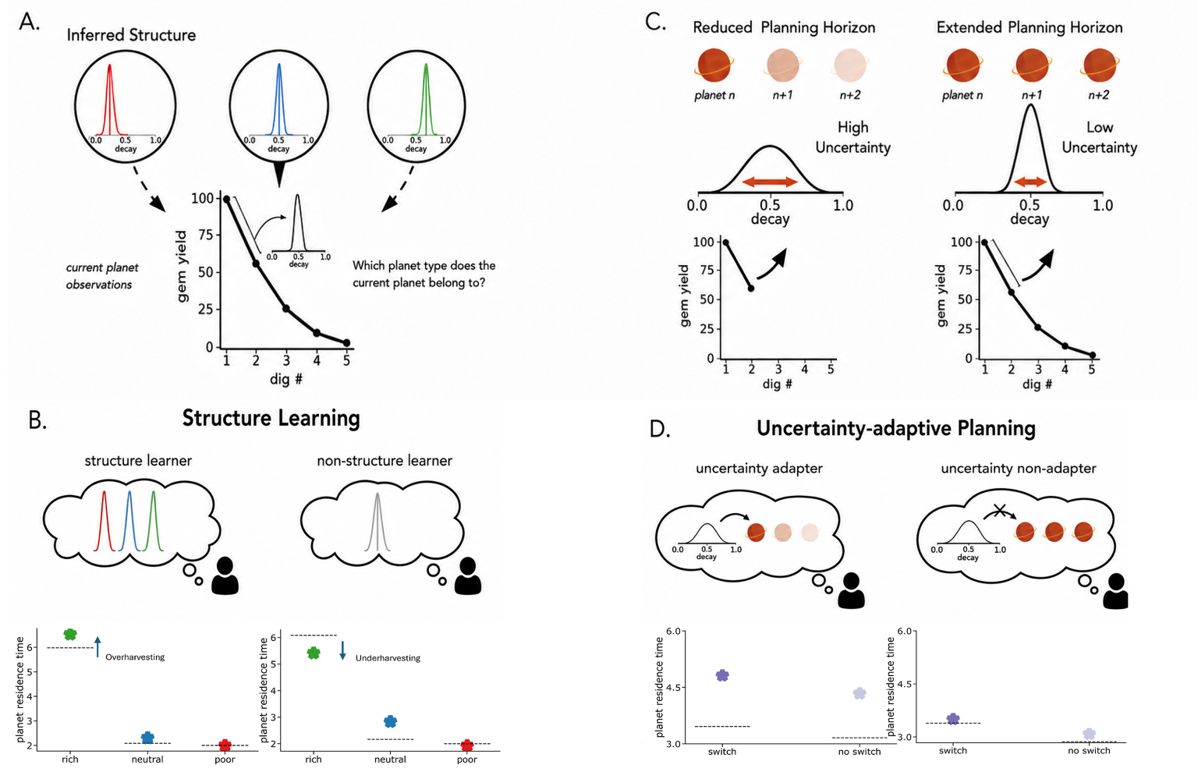

Computational framework for structure learning and uncertainty-dependent planning. (A) The forager performs two concurrent inferences: estimating the latent type of the current planet from experienced rewards and inferring the overall number of distinct planet types in the environment. We formalize this procedure as a Chinese Restaurant Process. (B) Model predictions from structure learning. The inferred complexity of the environment is controlled by the parameter $α$, which governs how readily new planet types are introduced. Different assumptions about environmental structure lead to systematic differences in harvesting behavior. Points denote simulated planet residence times (PRTs), and dashed lines indicate the Marginal Value Theorem (MVT) benchmark. (C) Uncertainty-dependent planning. The model assumes that the planning horizon is dynamically adjusted based on uncertainty about the current planet’s identity, with higher uncertainty promoting shorter planning horizons and lower uncertainty supporting longer-term planning. (D) Behavioral consequences of uncertainty modulation. Agents that adjust planning according to uncertainty exhibit increased overharvesting following infrequent transitions between planet types, whereas agents with fixed planning horizons show more stable residence times across environments. (Figure adapted with permission from Harhen et al., (2026).)

Adaptive Discounting Model
To characterize how participants inferred environmental structure and adjusted their decisions under uncertainty, we fit a Bayesian structure-learning and uncertainty-adaptive planning model adapted from recent work (Harhen and Bornstein 2023; Harhen et al. 2026; Chen et al. 2026).

Structure Learning
Unlike the Marginal Value Theorem (MVT), which assumes perfect knowledge of patch types and their depletion dynamics, the current model assumes that foragers must infer the latent structure of the environment. Specifically, participants do not know (i) how many planet types exist, (ii) which planets belong to which type, or (iii) the depletion distribution governing each type.
We model structure inference using a Chinese Restaurant Process, CRP (Antoniak 1974), a nonparametric Bayesian prior that allows the number of latent planet types to grow with experience. Under the CRP prior the probability that a newly encountered planet belongs to an existing cluster $k$ is proportional to the number of previously assigned planets in that cluster:
$$P(k)=\left\{\begin{matrix}\frac{n_{k}}{N+α}, & \text{if }k\text{ is old} \\ \frac{α}{N+α}, & \text{if }k\text{ is new}\end{matrix}\right.$$
where $n_{k}$ is the number of planets assigned to cluster $k$, $N$ is the total number of planets encountered, and $α$ governs the complexity of inferred structure. Larger values of $α$ favor the creation of additional clusters.
After observing a sequence of depletions $D$ on the current planet, the posterior probability that the planet belongs to cluster $k$ is:
$$P(k∣D)=\frac{P(D∣k)P(k)}{\sum_{j=1}^{J}{P}(D∣j)P(j)}$$
where $j$ is the number of clusters formed thus far.
Because exact inference over cluster assignments is computationally intractable, we approximate the posterior using a particle filter (Djuric et al. 2003). Each particle represents a candidate clustering of previously encountered planets and is weighted according to its likelihood. Upon leaving a planet, particles are resampled in proportion to their weights, favoring representations that better explain observed reward dynamics. Each particle maintains a hypothetical clustering of planets, weighted by the likelihood of the data given that clustering. All simulations and fittings were done using a single particle, equivalent to Anderson’s local MAP algorithm (Anderson 1991).
Each cluster maintains a Gaussian distribution over decay rates:
$$d_{k}∼N(μ_{k},σ_{k})$$
Cluster parameters are updated analytically using conjugate Normal–Gamma updates after each observed depletion.
To predict the next depletion, we use a Monte Carlo sampling procedure. For each simulation step: (1) a particle is sampled proportional to its weight, (2) a cluster is sampled from that particle’s posterior, and (3) a decay rate is drawn from the sampled cluster’s distribution. This process is repeated multiple times, and the sampled decay rates are averaged to generate the predicted depletion used for value computation.

Uncertainty-Adaptive Planning
Because structure inference is inherently uncertain, foragers must decide how far into the future to plan under epistemic uncertainty. Following prior work (Jiang et al. 2015; Harhen and Bornstein 2023; Harhen et al. 2026; Chen et al. 2026), we model planning horizon adjustments via adaptive discounting of future rewards.
Representational uncertainty is quantified as the Shannon entropy of the multinomial distribution over planet types:
U=-i​pilogpi
where $p_{i}$ denotes the posterior probability of cluster $i$.
The effective discount factor governing planning depth is defined as a logistic function of baseline discounting and uncertainty sensitivity:
$$γ_{\text{effective}}=\frac{1}{1+e^{-(γ_{\text{base}}+γ_{\text{coef}}⋅U)}}$$
Here, $γ_{\text{base}}$ captures baseline planning horizon, while $γ_{\text{coef}}$ quantifies the extent to which structural uncertainty modulates discounting.
Importantly, uncertainty in our task is not correlated with trial number (Supplementary Figure S5), ensuring that uncertainty-dependent effects cannot be attributed to time-on-task or learning progression.
At each decision point, the value of staying was defined as the expected reward from one additional dig:
$$V_{\text{stay}}=r_{t}⋅{\hat{d}}_{t}$$
where $r_{t}$ is the reward obtained on the previous dig and ${\hat{d}}_{t}$ is the predicted depletion rate.
The value of leaving was defined as the opportunity cost of doing another dig on the current planet:
$$V_{\text{leave}}=\frac{r_{\text{total}}}{t_{\text{total}}}⋅t_{\text{dig}}$$
where $r_{\text{total}}/t_{\text{total}}$ is the global reward rate experienced so far and $t_{\text{dig}}$ is the time required to complete one additional dig.

Action Selection
Given predicted values for staying and leaving, decisions are generated via a softmax choice rule with lapse:
$$p_{\text{stay}}=(1-ϵ)\frac{1}{1+e^{-(V_{\text{stay}}-V_{\text{leave}})}}+\frac{ϵ}{2}$$
where $ϵ$ is a lapse parameter capturing stimulus-independent random responses. The lapse term captures the idea that a small proportion of choices may be made independently of the model’s value estimates, accounting for occasional inattentive or accidental responses.
This model dissociates two components of adaptive behavior: (1) the uncertainty of inferred environmental structure and (2) the extent to which uncertainty in that structure shapes planning depth. Together, these parameters allow us to test whether life experiences are associated with differences in structural representation, uncertainty-adaptive planning, or both.

Parameter Recovery Analysis
To assess the identifiability of model parameters and the reliability of individual-differences inference, we conducted a parameter recovery analysis using simulated datasets. Parameter recovery evaluates whether the model-fitting procedure can recover known generative parameters and, critically for the present study, whether it preserves between-subject variability in those parameters.

Simulation Procedure
We simulated behavior for 200 agents performing the full task using the identical trial structure as human participants. For each simulated agent, parameters were independently drawn from broad uniform distributions spanning plausible ranges:
$$γ_{\text{base}}∼\text{Uniform}(-10,10)$$
$$γ_{\text{coef}}∼\text{Uniform}(-3,3)$$
$$α∼\text{Uniform}(0,10)$$
$$ϵ∼\text{Uniform}(0,0.1)$$
The simulation agents generated stay–leave decisions using the full adaptive discounting model, including CRP-based structure learning, particle filtering, uncertainty-dependent discounting, and softmax action selection with lapse.

Model Refitting
Each simulated dataset was refit using the same maximum likelihood estimation procedure applied to human participants. The fitting procedure estimated the three theoretically central parameters of the adaptive discounting model: the structure complexity parameter ($α$), baseline discounting ($γ_{\text{base}}$), and uncertainty-sensitive discounting ($γ_{\text{coef}}$). The lapse parameter ($ϵ$) was not estimated during fitting and was instead used only as simulation noise during data generation.
Because the primary goal of the present study is to examine individual differences (e.g. associations between model parameters and early-life unpredictability), our recovery evaluation focused on whether the fitting procedure preserves variability across agents. Recovery quality was quantified using Spearman correlation between true and fitted parameters across simulated agents.

Recovery Results
Baseline discounting ($γ_{\text{base}}$) demonstrated robust recovery in rank space (Spearman $ρ=0.65$; Supplementary Fig. S1B). Similarly, uncertainty sensitivity ($γ_{\text{coef}}$) showed strong recovery (Spearman $ρ=0.71$; Supplementary Fig. S1C), indicating that the model reliably preserves individual variability in baseline planning horizon and uncertainty-dependent discounting.
For the structure learning parameter $α$, we examined recovery after discretizing parameter values according to the modal number of inferred latent clusters produced by simulation of the CRP process. This is because the behavioral influence of $α$ is mediated through the number of inferred latent clusters, which changes discretely rather than continuously as $α$ varies. Consequently, small changes in $α$ do not necessarily produce proportional changes in observed behavior, reducing the identifiability of exact continuous parameter values. (See Supplementary Fig. S1A for the comparatively poor recovery of $α$ in continuous space.) Under this discretized representation, recovery performance was stronger (hit rate = 0.69; Supplementary Fig. S1D), indicating that the model reliably captures behaviorally relevant differences in inferred environmental structure complexity.

Preregistered Replication
An independent, preregistered replication sample was recruited through Prolific in October 2026. Participants completed the same patch-leaving task and questionnaires as the original sample, with 197 participants included in the final replication analyses. The preregistration record is linked at the end of the manuscript.

Results

Task structure and model-derived parameters predict over harvesting.
To validate the task manipulation, we first examined whether participants’ stay-leave behavior was sensitive to the reward structure of the task. We found that planet residence time (PRT) scaled with environmental richness: participants stayed longest in rich patches, intermediately in neutral patches, and shortest in poor patches (Fig. 3A). Pairwise comparisons confirmed robust richness-dependent adjustments in PRT (rich vs. neutral: t(146) = 21.92, p < .001; neutral vs. poor: t(146) = 15.43, p < .001). These effects indicate that participants tracked local reward statistics and adapted their stay-leave behavior accordingly.

Participants’ behavior also became more aligned with the Marginal Value Theorem (MVT) optimum over time. Across the task, their PRT moved closer to the MVT optimum as the absolute deviation between observed PRT and the MVT optimum decreased from the first to the final block (t(146) = −2.77, p = .006). This pattern suggests that participants’ behavior became increasingly sensitive to the task’s reward structure with experience.

A central prediction of our adaptive discounting model is that uncertainty should bias participants toward staying longer in the current patch by reducing the subjective value of leaving. To test this prediction behaviorally, we compared trials following rare patch-type switches with trials following common no-switch transitions. As expected, participants took longer to respond after a switch, consistent with increased decision uncertainty (Fig. 3B; t(146) = 2.81, p = .006). They also overharvested more following a switch, as indexed by higher PRT relative to the MVT optimum (Fig. 3C; t(146) = 3.14, p = .002). Together, these findings provide preliminary model-consistent behavioral evidence that transition uncertainty promotes longer staying.

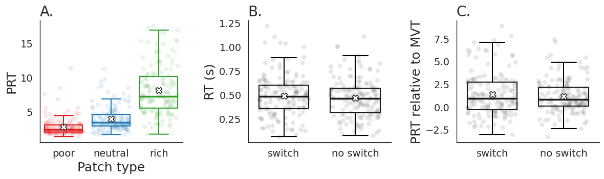
Figure 3: Environmental richness and transition uncertainty shape foraging behavior. (A) Mean planet residence time (PRT) differed systematically across patch types, with longer stays in richer environments. (B) Reaction times (RTs) were longer following rare patch-type switches than following common no-switch transitions. (C) Participants overharvested more following a switch, as indexed by larger PRT relative to the MVT optimum

After establishing that participants were sensitive to task structure and transition uncertainty, we next examined whether individual differences in model parameters captured meaningful variation in overharvesting. Overharvesting, defined as actual PRT relative to the PRT suggested by Marginal Value Theorem (MVT), was strongly associated with baseline discounting parameter γ_{base} (Fig. 4B; r = −0.92, p = 7.6 × 10−62), confirming that individuals who discounted future values were more likely to stay in the current patch. Importantly, additional variation in overharvesting was also associated accounted for by the uncertainty-sensitive component of the discount factor, γ_{coef} (Fig. 4C; r = 0.22, p =.0088), linking a computational signature of subjective uncertainty to a directly observable behavioral consequence—namely, staying longer than optimal. We observed a wide range of individual differences: distributions of model-derived parameters and behavioral measures are shown in Supplementary Figure S2.

Early-life unpredictability is associated with overharvesting through uncertainty-sensitive discounting
Having established that uncertainty-sensitive discounting was associated with overharvesting, we tested whether early-life unpredictability was associated with uncertainty-sensitive discounting. This computational signature of uncertainty-sensitive planning. Among the six ELU factors, only ELU Factor 1 showed a reliable association with the uncertainty-sensitive discounting parameter γ_{coef} (Fig. 4A; r = 0.31, p = .00017). This relationship remained significant after correction for multiple comparisons across all six ELU factors (Bonferroni-corrected p = .014), indicating that individuals reporting greater early-life unpredictability exhibit stronger trial-by-trial discounting under uncertainty.

Given that the discounting parameter γ_{coef} was associated with both ELU (Fig. 4A) and overharvesting (Fig. 4C), we tested whether ELU influenced behavior indirectly. Single-mediator analyses revealed a consistent indirect association between ELU factor 1 and overharvesting via γ_{coef} across task environments. For poor environments, ELU significantly predicted overharvesting (total effect: c = 0.1103, p < .001 ), and this effect was partially mediated by γ_{coef} (indirect effect: ab = 0.0288, 95% CI [0.0114, 0.0540]) , with the direct effect remaining significant (c′ = 0.0816, p < .001). For neutral environments, the total effect was significant (c = 0.1188, p < .001), and the direct effect also remained significant (c′ = 0.0855, p = .004), alongside a significant indirect effect through uncertainty-sensitive discounting (ab = 0.0333, 95% CI [0.0086, 0.0651]). For rich environments, the total effect was significant (c = 0.1585, p = .005), whereas the direct effect was not significant (c′ = 0.1104, p = .055); however, the indirect effect remained significant (ab = 0.0482, 95% CI [0.0066, 0.1073]). These environment-specific indirect effects remained significant after FDR correction across the three environments (all qs ≤ .014).

To test whether this indirect association generalized across task environments, we performed a single mediation analysis across all planet types at the subject level. Across all environments, ELU factor 1 showed significant total effect on predicting overharvesting (total effect: c = 0.1261, p < .001). Further, the indirect effect through γ_{coef} was significant (ab = 0.0361, 95% CI [0.0096, 0.0744]), while the direct effect remained significant after accounting for γ_{coef} (c′ = 0.0900, p = .009), consistent with partial mediation.Parallel mediation analyses that included both γ_{coef} and γ_{base} further showed that only the indirect pathway through γ_{coef} was significant(indirect effect via γ_{coef} :0.0298, 95% CI [0.0096, 0.0526], FDR-corrected q = .008) , whereas the indirect pathway through γ_{base} was not significant (indirect effect via γ_{base} : 0.0371,95% CI [−0.0086, 0.0737], q = .100). Together, these results indicate that early-life unpredictability behavior is associated with greater overharvesting through increased uncertainty-sensitive discounting, consistent with theoretical proposals (Harhen and Bornstein, 2024). Specifically, ELU is associated with increased uncertainty-sensitive discounting, which in turn predicts overharvesting relative to the MVT benchmark. Consistent with this interpretation, ELU retained a direct association with aggregate overharvesting, while the indirect pathway through uncertainty-sensitive discounting also remained significant. This result emphasizes the influence of early-life unpredictability on specific computational components of planning and choice while also indicating an additional direct association with observed behavior.

We also tested whether these adversity-related measures were associated with the structure-learning parameter α. In contrast to γ_{coef}, α was not significantly correlated with any ELU factor (Spearman ρ range = −0.018 to 0.138, all ps ≥ .096, all FDR-corrected qs ≥ .450), any LEC-derived trauma-load score (ρ range = −0.037 to 0.018, all ps ≥ .656, all qs ≥ .908), or any PCL-derived factor (ρ range = −0.143 to −0.061, all ps ≥ .085, all qs ≥ .450).Thus, the associations with early-life unpredictability appeared specific to uncertainty-sensitive discounting rather than reflecting broad differences in inferred environmental structure.
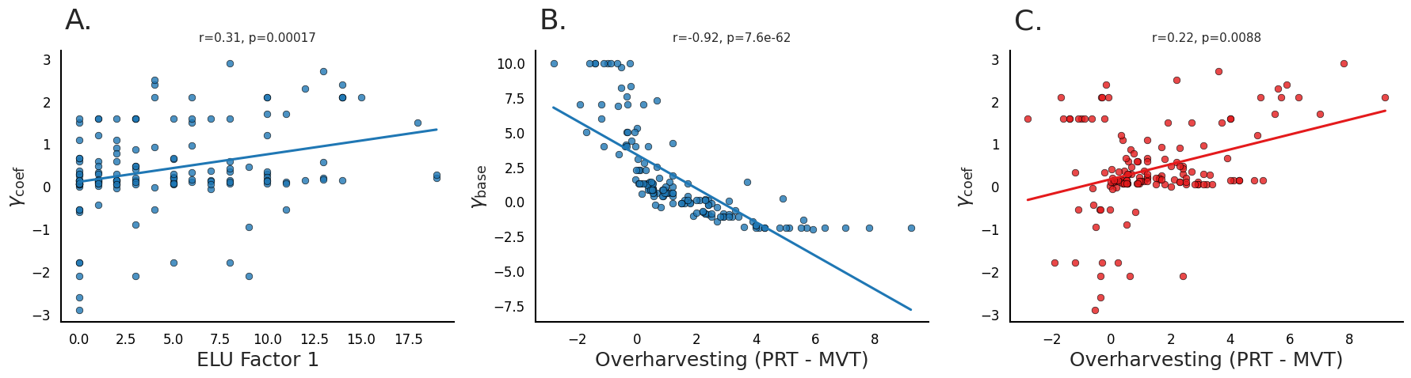

Figure 4: Behavioral deviations from optimal foraging relate to model-derived dis-counting parameters. (A) ELU Factor 1 was positively associated with γ_{coef}, indicating stronger uncertainty-sensitive discounting. (B) Greater overharvesting was strongly associated with lower γ_{base}, indicating that individual differences in discounting future rewards irrespective of local uncertainty could contribute to overharvesting behavior. (C) Greater overharvesting was also associated with the higher γ_{coef}, indicating stronger uncertainty-dependent discounting and supporting the idea that individual differences in overharvesting were further modulated by local uncertainty.

Early-life-unpredictability, but not PTSD symptom severity, predicts uncertainty-sensitive discounting
After showing that ELU was associated with uncertainty-sensitive discounting, we next asked whether this association was specific to early-life unpredictability or could instead be explained by trauma-related symptom severity. To test this, we examined whether individual differences in early-life unpredictability (ELU) and Post-Traumatic Stress Disorder Checklist (PCL) uniquely predicted with the uncertainty-sensitive discounting parameter, γ_{coef} . As with ELU, γ_{coef} was positively correlated with the total PCL score (Fig. 5A; r = 0.26, p = 1.8 × 10−3), suggesting that individuals with greater trauma-related symptoms exhibited a stronger modulation sensitive on online uncertainty. However, PCL total was also strongly correlated with overall ELU measured by QUIC total (Fig. 5B; r = 0.50, p = 1.1 × 10−10), indicating substantial shared variance.

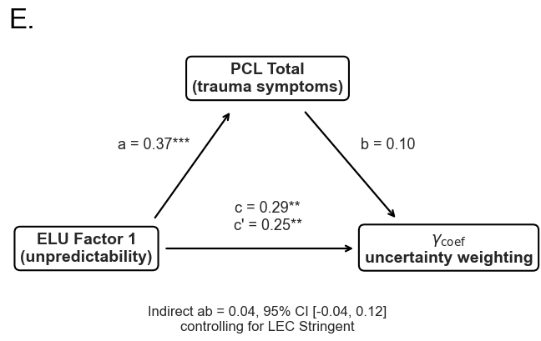
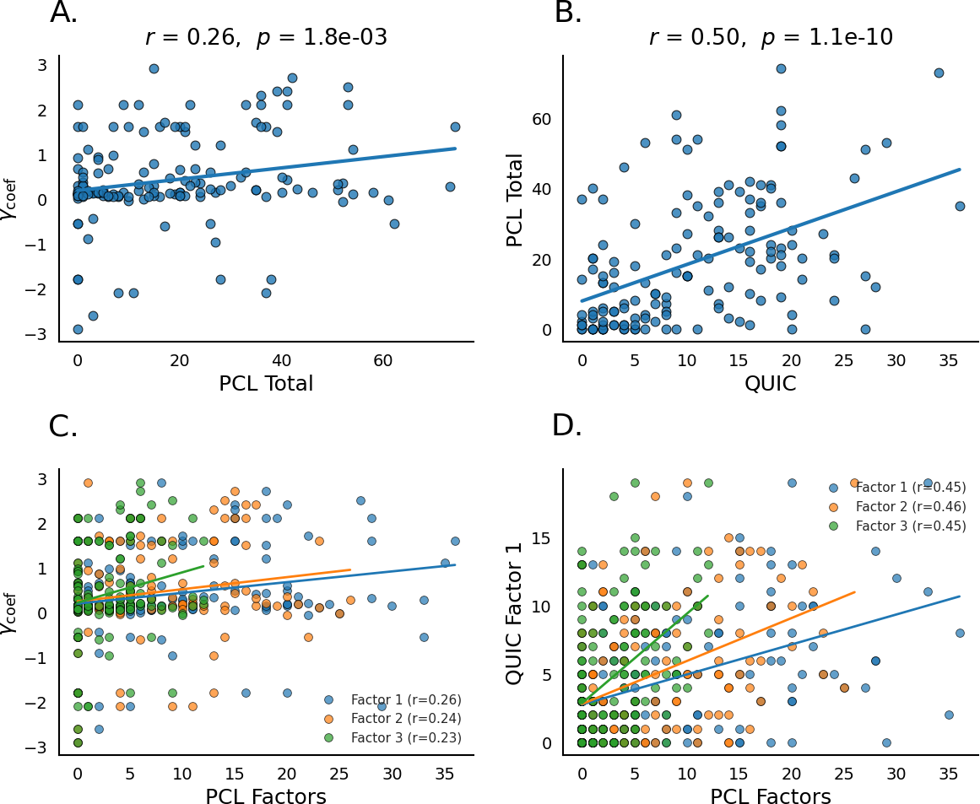

Figure 5: Dissociation between early-life unpredictability and PTSD symptoms in predicting uncertainty-sensitive discounting. (A) γ_{coef} is positively correlated with PCL total. (B) PCL total is strongly correlated with QUIC total. (C) γ_{coef} shows weak positive correlations with PCL-derived factors. (D) PCL-derived factors are moderately correlated with ELU Factor 1. (E) Mediation analysis testing whether the association between ELU factor 1 total and γ_{coef} is mediated by PCL total while controlling for LEC.

To better characterize this overlap, we examined factor-level structure. γ_{coef} showed moderate positive correlations with each of the three PCL-derived factors (Fig. 5C; rs ≈ 0.23–0.26, p ≈ 1.6 × 10−3 – 6.7 × 10−3). Importantly, ELU Factor 1 was also positively correlated with all PCL factors (Fig. 5D): PCL Factor 1 (r = 0.45, p = 8.52 × 10−8), PCL Factor 2 (r = 0.46, p = 1.65 × 10−8), and PCL Factor 3 (r = 0.45, p = 8.05 × 10−9). These results indicate that greater early-life unpredictability was broadly associated with elevated trauma-related symptom dimensions. To determine whether ELU or PTSD symptom severity uniquely explained variance in uncertainty-sensitive discounting, we next performed multiple regression analyses including both ELU and PCL measures as simultaneous predictors of γ_{coef} . When ELU Factor 1 and total PCL score were entered together into the same model, only ELU Factor 1 uniquely predicted γ_{coef} (β = 0.25, p = .006), whereas PCL total no longer explained unique variance (β = 0.10, p = .262). Similarly, when ELU Factor 1 and all three PCL-derived factors were included, again only ELU Factor 1 significantly predicted γ_{coef} (β = 0.25, p = .007), whereas none of the individual PCL factors were significant predictors (all ps > .38).

We further tested whether the relationship between early-life unpredictability and uncertainty-sensitive discounting persisted after adjusting PTSD symptom severity and lifetime trauma exposure measured by the LEC-5 (Fig. 5E). To preserve the temporal logic of the model, ELU Factor 1 was treated as the predictor, PCL total as a concurrent symptom measure, and γ_{coef} as the outcome. Path analyses controlling for LEC-derived trauma-load showed a consistent pattern across conservative, stringent, and liberal scoring criteria. ELU Factor 1 significantly predicted PCL total after controlling for LEC trauma-load (path a: β = 0.31–0.37, all ps < .001), suggesting that greater early-life unpredictability was associated with greater PTSD symptom severity. However, PCL total did not significantly predict γ_{coef} after controlling for ELU Factor 1 and LEC trauma-load (path b: β = 0.10–0.14, all ps > .14). In contrast, ELU Factor 1 showed a significant total effect with γ_{coef} after controlling for LEC trauma-load (total effect c: β = 0.28–0.33, all ps < .01), and this association remained significant after controlling for PCL total (direct effect c′: β = 0.24–0.29, all ps < .05). The indirect effect through PCL was not significant across any LEC scoring definition (conservative: ab = 0.044, 95% CI [−0.026, 0.118]; stringent: ab = 0.038, 95% CI [−0.044, 0.116]; liberal: ab = 0.034, 95% CI [−0.047, 0.110]). Thus, PTSD symptom severity did not mediate the association between ELU and uncertainty-sensitive discounting.
Together, our analyses show that early-life unpredictability predicts individual differences in uncertainty-sensitive discounting even after adjustment for current PTSD symptom severity and lifetime trauma exposure, suggesting that uncertainty-sensitive decision-making is more closely linked to developmental unpredictability than to PTSD symptoms or lifetime trauma-load alone.

Preregistered replication provides converging evidence for ELU-associated uncertainty-sensitive discounting

To assess the robustness of our findings, we conducted a pre-registered independent replication analysis using an additional sample of participants (N = 197). Consistent with the original sample, ELU Factor 1 was positively associated with uncertainty-sensitive discounting γ_{coef}, (Spearman ρ = 0.192, p = .007; Fig. 6A). Both baseline discounting (γ_{base}; ρ = −0.353, p < .001) and uncertainty-sensitive discounting (γ_{coef}; ρ = 0.187, p = .009; Fig. 6B) were significantly associated with overall overharvesting, replicating the original sample. Mediation analyses further showed significant indirect association between ELU Factor 1 and overall overharvesting through γ_{coef} (ab = 0.039, 95% CI [0.004, 0.082]; Fig. 6C). This indirect effect was significant in poor (ab = 0.042, 95% CI [0.006, 0.088], FDR-corrected q = .018) and neutral environments (ab = 0.056, 95% CI [0.011, 0.108], q = .018), but not in rich environments (ab = 0.030, 95% CI [−0.003, 0.069], q = .088). Neither the total nor direct effects of ELU on overharvesting were significant, suggesting that the replication primarily supported an indirect association through uncertainty-sensitive discounting.

Next, we tested whether the specificity of the ELU–uncertainty discounting relationship relative to trauma-related symptom severity was preserved in the replication sample. Unlike the original sample, PCL total was not significantly correlated with γ_{coef} (ρ = 0.098, p = .172; Fig. 6D), although ELU Factor 1 remained positively associated with PCL total (ρ = 0.416, p < .001; Fig. 6E). Mediation analyses controlling for lifetime trauma exposure using the three LEC scoring criteria revealed a consistent pattern (Fig. 6F). ELU Factor 1 significantly predicted PCL total (path a: β = 0.341–0.399, all ps < .001), whereas PCL total did not independently predict γ_{coef} (path b: β = 0.030–0.034, all ps > .67). Importantly, ELU retained a significant direct association with γ_{coef} after controlling for PCL and LEC (c′ = 0.190–0.193, all ps < .017), while the indirect effects through PCL remained nonsignificant (all FDR-corrected qs = .709). Together, these results largely replicate the original findings, supporting a specific association between early-life unpredictability and uncertainty-sensitive discounting that is not accounted for by PTSD symptom severity or lifetime trauma exposure.

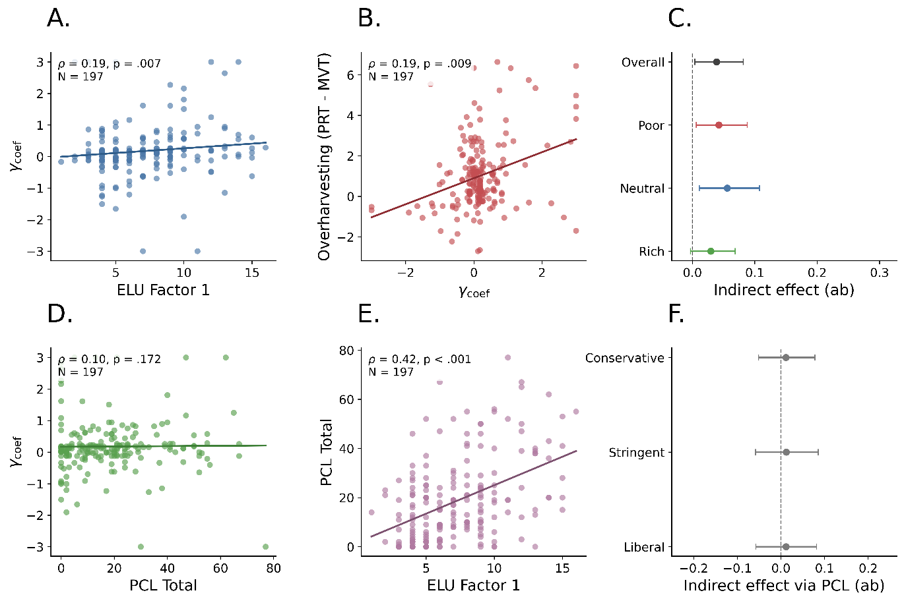

Figure 6: Preregistered independent replication. (A) ELU Factor 1 was positively associated with the uncertainty-sensitive discounting parameter γ_{coef}. (B) Greater γ_{coef} was associated with increased overharvesting relative to the Marginal Value Theorem (MVT) optimum. (C) Mediation analyses demonstrated significant indirect associations between ELU Factor 1 and overharvesting through γ_{coef} overall and in poor and neutral environments, but not in rich environments. Points indicate estimated indirect effects (ab), with horizontal bars representing bootstrap 95% CI. (D) PCL total was not significantly correlated with γ_{coef}. (E) ELU Factor 1 was positively associated with PCL total. (F) Mediation analyses controlling for lifetime trauma exposure using conservative, stringent, and liberal LEC scoring criteria showed that the direct association between ELU Factor 1 and γ_{coef} remained significant, while the indirect effect through PCL total was not significant under any scoring criterion. Correlations were assessed using Spearman's ρ; mediation analyses used standardized rank-based regression with 1,000 bootstrap resamples.

Discussion

In our present study, we investigated whether early-life unpredictability (ELU) sequential is associated with stay-leave decisions under uncertainty. Using a structured patch foraging task and a computational model of uncertainty-adaptive planning, we showed that ELU was associated with uncertainty-sensitive discounting. Individuals reporting higher ELU showed stronger -greater modulation of choice values under uncertainty, which predicted systematic overharvesting relative to the Marginal Value Theorem (MVT) benchmark. These associations were reproduced in an independent, preregistered replication sample. Mediation analyses across both samples further supported an indirect association between ELU and overharvesting through uncertainty-sensitive discounting, suggesting that early-life experience may shape decision-making through its influence on how uncertainty is weighted in planning and valuation.

Our findings build on recent theoretical work proposing that unpredictability during sensitive developmental period selectively alters psychiatric symptoms and neural systems involved in representing uncertainty and future expectations (Baram et al., 2012; Birnie and Baram, 2022; Spadoni et al., 2022). We identify a computational pathway that links ELU to behavior in a naturalistic foraging task. In our model, uncertainty reduces the effective planning horizon by discounting the value of leaving a patch. Participants with greater ELU therefore behaved as if uncertain future reward were less valuable, biasing them toward overharvesting in current patch. With our structural learning modeling, we replicate and extend prior work by showing that human overharvesting can emerge from rational adaptation to latent environmental uncertainty rather than from simple failures of self-control or impulsivity (Constantino and Daw, 2015; Harhen and Bornstein, 2023; Harhen et al., 2026; Chen et al., 2026). Within this framework, overharvesting reflects a computationally meaningful consequence of uncertainty-sensitive planning. Our results suggest that ELU systematically shifts the degree to which uncertainty shapes future-oriented valuation.

We were primarily interested in the dissociation between early-life unpredictability, PTSD symptom severity, and lifetime trauma exposure. Although PTSD symptoms initially showed positive associations with uncertainty weighting, these effects were accounted for by variance shared with ELU. Once ELU and PCL factors were modeled simultaneously, only ELU uniquely predicted uncertainty sensitivity. We further showed that the ELU association with uncertainty-sensitive discounting persisted after adjustment for both current PTSD symptoms and LEC-derived lifetime trauma-load. In the revised path model, ELU significantly predicted PCL total, but PCL total did not significantly predict uncertainty-sensitive discounting after controlling for ELU and LEC trauma-load. In contrast, the direct association between ELU and uncertainty-sensitive discounting remained significant after controlling both PCL and LEC, and the indirect effect through PCL was not significant. This pattern suggests that the link between ELU and uncertainty-sensitive planning is not explained by current PTSD symptom severity or cumulative lifetime trauma exposure alone.

Importantly, this does not imply that trauma exposure or PTSD symptoms are unrelated to decision-making under uncertainty. Rather, the present results suggest that the specific computational parameter examined here was more closely associated with early-life unpredictability than with trauma-related symptom severity or lifetime trauma-load in this sample. Because our participants were not selected for clinically elevated PTSD symptoms, it remains possible that PTSD-related effects would be stronger in a more symptomatic or trauma-exposed population. Nonetheless, the present findings are informative because they show that ELU-related variation in uncertainty-sensitive valuation can be detected even in a relatively lower-risk adult sample. More broadly, these results support emerging perspectives arguing that unpredictability during sensitive developmental periods may calibrate core inferential and evaluative systems that persist into adulthood (Birnie and Baram, 2022; Harhen and Bornstein 2024). Our findings also expand on recent work showing that early-life experience alters exploration in repeated choice tasks (Xu et al. 2023) —though, critically, the same study did not find an effect of early-life experience on exploration in a sequential foraging environment, perhaps due to using a single-patch design which did not manipulate uncertainty as we do here.

Future work could further extend this framework to environments in which participants voluntarily choose transitions among distinct patch types, where choices may be influenced by uncertainty sensitivity (Charnov, 1976). Further, combining computational modeling with neuroimaging could clarify how ELU shapes representations of environment states–are these states merged in individuals with higher subjective uncertainty, or does uncertainty modulation affect the value computations alone? Similarly, foraging in the real world is often performed under threat of predation. Therefore, it will be valuable to examine how the influences of early-life and lifelong experiences influence choices in these environments (Leonard et al. 2026; Sloan et al.2025). Finally, the present findings also raise questions for future work on the neural mechanisms linking developmental experience to uncertainty-guided decision-making. Sequential foraging requires maintaining beliefs about hidden environmental structures, estimating transition uncertainty, and planning for future actions (Stachenfeld et al., 2017; Duvelle et al., 2023; Shenhav et al., 2014; Hayden et al., 2011; Nussenbaum & Hartley 2024).

Our study is not without limitations. First, the present data cannot establish causal developmental effects of ELU on uncertainty-sensitive planning. Longitudinal and experimentally informed designs will be needed to test whether unpredictability prospectively shapes later uncertainty-guided decision-making. Similarly, the current study relied on retrospective self-report measures of unpredictability and trauma exposure, which may be influenced by recall biases (Zhang et al., 2026). However, prior validation work linking retrospective QUIC items to prospective measures of unpredictability reduces, though does not eliminate, this concern. In addition, the LEC-5 indexes cumulative lifetime exposure rather than the timing of traumatic events. Future work should directly assess the developmental timing and recency of traumatic experiences.

In summary, across an original study and a preregistered independent replication, we show that early-life unpredictability is associated with increased uncertainty-sensitive discounting during sequential foraging. This latent computational phenotype predicts systematic overharvesting relative to normative foraging benchmarks and mediates the relationship between developmental unpredictability and behavior. By dissociating the influence of early-life unpredictability from trauma symptom severity, the present work provides evidence that developmental unpredictability selectively shapes how uncertainty is incorporated into planning and valuation. These findings support the broader idea that early environments calibrate core computational mechanisms underlying adaptive behavior under uncertainty.

Data Availability
All data and code can be found in the GitHub link:
https://github.com/zyxl100/foraging_MQLP_2026
Preregister information link: https://researchbox.org/edit_box.php

Acknowledgments
AMB acknowledges funding from NIMH (R01MH061285, PI: SJ Pollak; P50MH096889, PI: TZ Baram).

Disclosures
No conflicts of interest, financial or otherwise, are declared by the authors.

Author Contributions References

Anderson, J. R. (1991). The adaptive nature of human categorization. Psychological review,
98(3):409.

Antoniak, C. E. (1974). Mixtures of dirichlet processes with applications to bayesian non-parametric problems. The annals of statistics, pages 1152–1174.
Baram, T. Z., Davis, E. P., Obenaus, A., Sandman, C. A., Small, S. L., Solodkin, A., and Stern, H. (2012). Fragmentation and unpredictability of early-life experience in mental disorders. American Journal of Psychiatry, 169(9):907–915.
Bird, B. M., Levitt, E. E., Stewart, S. H., Wanklyn, S. G., Meyer, E. C., Murphy, J. G., ... & Mackillop, J. (2024). Posttraumatic stress and delay discounting: a meta-analytic review. Psychological medicine, 54(3), 437-446.
Birnie, M. T. and Baram, T. Z. (2022). Principles of emotional brain circuit maturation.
Science, 376(6597):1055–1056.

Blanchard, T. C. and Hayden, B. Y. (2015). Monkeys are more patient in a foraging task than in a standard intertemporal choice task. PloS one, 10(2):e0117057.
Charnov, E. L. (1976). Optimal foraging, the marginal value theorem. Theoretical population biology, 9(2):129–136.

Chen, X., Johnson, M., RA, P., Maxwell, M., Harhen, N., Noh, S., Bennett, I., and Bornstein, A. (2026). Age-related differences in structure learning drive foraging behavior in a multimodal patch-leaving task. In Cognitive Computational Neuroscience.
Constantino, S. M. and Daw, N. D. (2015). Learning the opportunity cost of time in a patch-foraging task. Cognitive, Affective, & Behavioral Neuroscience, 15(4):837–853.
Davis, E. P., & Glynn, L. M. (2024). Annual Research Review: The power of predictability–patterns of signals in early life shape neurodevelopment and mental health trajectories. Journal of Child Psychology and Psychiatry, 65(4), 508-534.
De Berker, A. O., Rutledge, R. B., Mathys, C., Marshall, L., Cross, G. F., Dolan, R. J., and Bestmann, S. (2016). Computations of uncertainty mediate acute stress responses in humans. Nature communications, 7(1):10996.
Decker, A. L., Leonard, J., Romeo, R., Itiat, J., Hubbard, N. A., Bauer, C., Grotzinger, H., Giebler, M. A., Torres, Y. C., Imhof, A., et al. (2025). Exploration is associated with socioeconomic disparities in learning and academic achievement in adolescence. Nature Communications, 16(1):6342.
Djuric, P. M., Kotecha, J. H., Zhang, J., Huang, Y., Ghirmai, T., Bugallo, M. F., and Miguez, J. (2003). Particle filtering. IEEE signal processing magazine, 20(5):19–38.
Duvelle, E´.,Grieves, R. M., and Van der Meer, M. A. (2023). Temporal context and latent state inference in the hippocampal splitter signal. Elife, 12:e82357.
Glynn, L. M., Stern, H. S., Howland, M. A., Risbrough, V. B., Baker, D. G., Nievergelt,
C. M., Baram, T. Z., and Davis, E. P. (2019). Measuring novel antecedents of mental illness: the questionnaire of unpredictability in childhood. Neuropsychopharmacology, 44(5):876–882.
Gray, M. J., Litz, B. T., Hsu, J. L., and Lombardo, T. W. (2004). Psychometric properties of the life events checklist. Assessment, 11(4):330–341.
Harhen, N. C. and Bornstein, A. M. (2023). Overharvesting in human patch foraging reflects rational structure learning and adaptive planning. Proceedings of the National Academy of Sciences, 120(13):e2216524120.
Harhen, N. C. and Bornstein, A. M. (2024). Interval timing as a computational pathway from early life adversity to affective disorders. Topics in cognitive science, 16(1):92–112.
Harhen, N. C., Budiono, R., Hartley, C. A., and Bornstein, A. M. (2026). Structure inference in complex environments improves from childhood to adulthood. Developmental Science, 29(3):e70163.
Hayden, B. Y., Pearson, J. M., and Platt, M. L. (2011). Neuronal basis of sequential foraging decisions in a patchy environment. Nature neuroscience, 14(7):933–939.
Jiang, N., Kulesza, A., Singh, S., and Lewis, R. (2015). The dependence of effective planning horizon on model accuracy. In Proceedings of the 2015 international conference on autonomous agents and multiagent systems, pages 1181–1189.
Leonard, B. T., Martinez-Ortiz, M. A., Bock, J., Zhang, Y., Flores, S., Taylor, D. V., ... & Bornstein, A. (2026). Anhedonia buffers the effects of early-life unpredictability on threat-reward decision-making. Biorxiv: the Preprint Server for Biology.
Morgado, P., Sousa, N., and Cerqueira, J. J. (2015). The impact of stress in decision making in the context of uncertainty. Journal of Neuroscience Research, 93(6):839–847.
Nussenbaum, K., & Hartley, C. A. (2024). Understanding the development of reward learning through the lens of meta-learning. Nature Reviews Psychology, 3(6), 424-438.
Porcelli, A. J., & Delgado, M. R. (2017). Stress and decision making: effects on valuation, learning, and risk-taking. Current opinion in behavioral sciences, 14, 33-39.
Rachum, A., Harten, L. M., Assa, R., Goldshtein, A., Chen, X., Gonceer, N., and Yovel,
Y. (2025). Early experience affects foraging behavior of wild fruit bats more than their original behavioral predispositions. eLife, 14:RP103220.
Shenhav, A., Straccia, M. A., Cohen, J. D., and Botvinick, M. M. (2014). Anterior cingulate engagement in a foraging context reflects choice difficulty, not foraging value. Nature neuroscience, 17(9):1249–1254.
Sloan, A. F., Kittleson, A. R., Torregrossa, L. J., Feola, B., Rossi-Goldthorpe, R., Corlett, P. R., & Sheffield, J. M. (2025). Belief updating, childhood maltreatment, and paranoia in schizophrenia-spectrum disorders. Schizophrenia bulletin, 51(3), 646-657.
Spadoni, A. D., Vinograd, M., Cuccurazzu, B., Torres, K., Glynn, L. M., Davis, E. P., Baram,
T. Z., Baker, D. G., Nievergelt, C. M., and Risbrough, V. B. (2022). Contribution of early-life unpredictability to neuropsychiatric symptom patterns in adulthood. Depression and anxiety, 39(10-11):706–717.
Stachenfeld, K. L., Botvinick, M. M., and Gershman, S. J. (2017). The hippocampus as a predictive map. Nature neuroscience, 20(11):1643–1653.
Verfaellie, M., Patt, V., Lafleche, G., Jones, D., and Vasterling, J. J. (2025). Choosing certainty over risk: Associations of ptsd symptom severity with memory sampling during experiential decision making. Journal of Anxiety Disorders, 110:102979.
Wortmann, J. H., Jordan, A. H., Weathers, F. W., Resick, P. A., Dondanville, K. A., Hall Clark , B., Foa, E. B., Young-McCaughan, S., Yarvis, J. S., Hembree, E. A., et al. (2016). Psychometric analysis of the ptsd checklist-5 (pcl-5) among treatment-seeking military service members. Psychological assessment, 28(11):1392.
Xu, Y., Harms, M. B., Green, C. S., Wilson, R. C., & Pollak, S. D. (2023). Childhood unpredictability and the development of exploration. Proceedings of the National Academy of Sciences, 120(49), e2303869120.
Zhang, Z., Zhou, C., Zhang, R., Tang, Y., Zhang, Y., Qin, P., Su, B., and Wang, Y. (2026). Depression shapes the recall of adverse childhood experiences: evidence from a three-wave longitudinal study of 6,260 chinese adolescents. Nature Mental Health, pages 1–12.

